Table of Contents

Get or connect to data 2

Identify and connect to data sources or a shared semantic model 2

Connect to a semantic model 4

Change data source settings, including credentials and privacy levels 4

Choose between DirectQuery and Import 6

Create and modify parameters 7

Profile and clean the data 8

Evaluate data, including data statistics and column properties 8

Resolve inconsistencies, unexpected or null values, and data quality issues 10

Resolve data import errors 13

Transform and load the data 17

Select appropriate column data types 17

Create and transform columns 17

Group and aggregate rows 17

Pivot, unpivot, and transpose data (x) 20

Convert semi-structured (JSON file) data to a table(x) 20

Create fact tables and dimension tables 20

Identify when to use reference or duplicate queries and the resulting impact 20

Reference : 21

Duplicate : 21

Merge and append queries 22

Identify and create appropriate keys for relationships 22

Configure data loading for queries 22

# Get or connect to data

## Identify and connect to data sources or a shared semantic model

You can connect easily to a data source thanks to the connector with Power Bi.

It exists several connectors, in our case we will use excel in local .

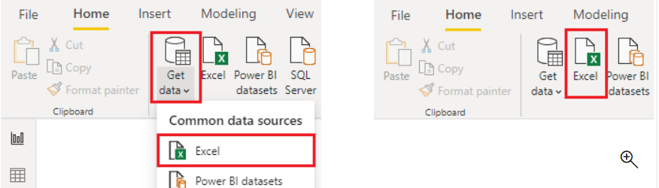

Now you can select the **Load** button to automatically load your data into the Power BI model or select the **Transform Data** button to launch the Power Query Editor, where you can review and clean your data before loading it into the Power BI model.

We often recommend that you transform data, but that process will be discussed later in this module. For this example, you can select **Load**.

Excel files might be in several locations, but the best is Onedrive for Business.

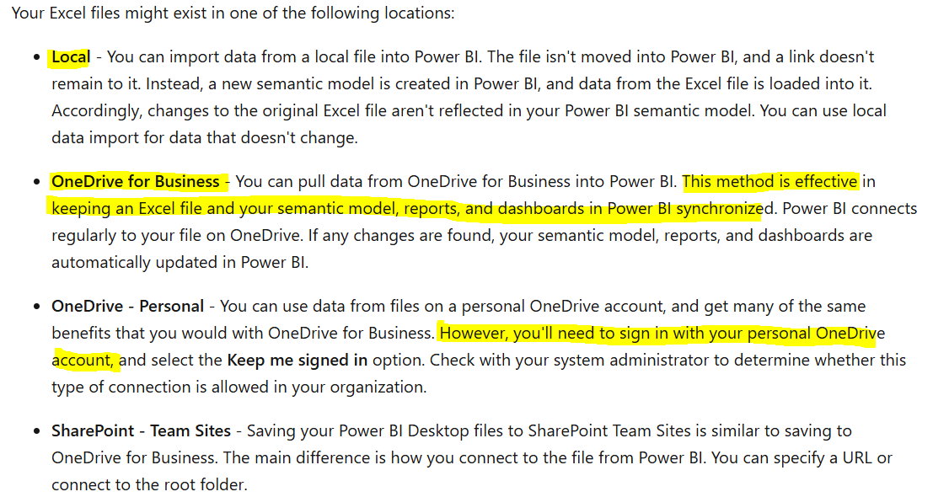

## Connect to a semantic model

## Change data source settings, including credentials and privacy levels

To change data source settings you should just go to power query and select source settings .

After you can change source or simply edit permissions.

Change source:

Edit permissions:

## Choose between DirectQuery and Import

## Create and modify parameters

You can create parameters to connect to the semantic model more easily and thanks to that create dynamic report.

Go to new parameter.

It will appear in the queries:

You can change it but before you should add it directly in the query editor , right click on the query (FactCmp..) => Advanced editor

Add **&Year**

You can do that for SQL queries etc..

You can create multiple parameters list .

See : <https://learn.microsoft.com/en-us/training/modules/get-data/3b-parameters> dynamic reports second part

# Profile and clean the data

## Evaluate data, including data statistics and column properties

You can do that analysis on the data source thanks to view, column profile distribution and quality .

The issue is that it is limited to 1000 rows but you can change this easily with

Click on it and entire dataset will appear.

## Resolve inconsistencies, unexpected or null values, and data quality issues

You can remove blank value just unselect from the column .

See result

You can replace value

If you have some errors in your dataset

Use replace by right click on the column and replace sales with nothing

NA replace by null

And filter without null value and change the type of the column

## Resolve data import errors

# Transform and load the data

## Select appropriate column data types

You can select the appropriate column data type in function of need .

## Create and transform columns

You can create custom column or example column



## Group and aggregate rows

You can group and aggregate data , it will reduce the size of your dataset improve performance.

You choose order date as base value :

You have the data aggregated with less row , you divide the size of the dataset and number of rows



## Pivot, unpivot, and transpose data

Unpivot converts column to row

Pivot converts row to column

Transpose example :

## Convert semi-structured (JSON file) data to a table

## Create fact tables and dimension tables

See model data

## Identify when to use reference or duplicate queries and the resulting impact

You can use reference when you want that the change on the source will impact your new table created as reference but if you want to isolate the source between them use duplicate.

### Reference :

When you use reference table all change in the source will impact the reference see :

I changed order date type to date , it has been automatically impact the second table

Be careful if you duplicate the reference the duplicate of the reference stays impacted by the first source.

### Duplicate :

Duplicates create a copy of the query copied without impacting the other , you keep also the steps and everything

## Merge and append queries

You will merge if you have for example a common key

And append if you have the same columns

You can create new table for both if you click on ... as new

## Identify and create appropriate keys for relationships

See model data

## Configure data loading for queries

You can easily choose which query will load or not .

It will avoid that some data load and refresh if not needed .

